**Aim**: Configuration Management with Ansible.

**Objectives:**

* Install and configure Ansible on Ubuntu.
* Set up SSH key-based authentication.
* Configure Ansible inventory.
* Run an Ansible playbook to manage configurations.

**Tools Used**: Virtual box, Ubuntu , Ansible

**Concepts:**

* Configuration Management: The process of maintaining and controlling software and system configurations consistently.
* Ansible Automation: A tool that automates IT tasks like configuration management, application deployment using YAML playbooks.
* SSH Key-Based Authentication: A secure method of logging into remote systems without passwords using cryptographic key pairs.

**Problem Statement**

To Install and configure Ansible on Ubuntu. To Set up SSH key-based authentication. To Configure Ansible inventory. To Run an Ansible playbook to manage configurations.

**Process:**

1. To configure the PPA on your system and install Ansible run these commands:

$ sudo apt update

$ sudo apt install software-properties-common

$ sudo add-apt-repository --yes --update ppa:ansible/ansible

$ sudo apt install ansible

And then check the ansible version  
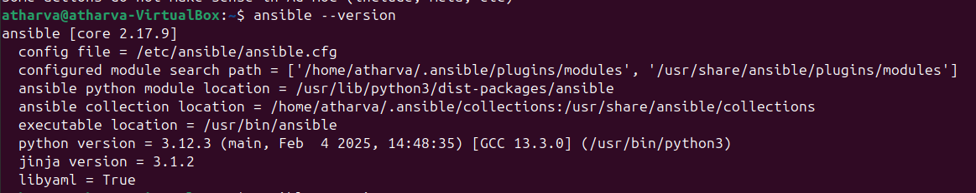

1. Now install SSH

sudo apt update

sudo apt install openssh-server -y

sudo systemctl enable ssh

sudo systemctl start ssh

1. Set Up SSH Key-Based Authentication

ssh-keygen

1. Copy the SSH Key to Client:

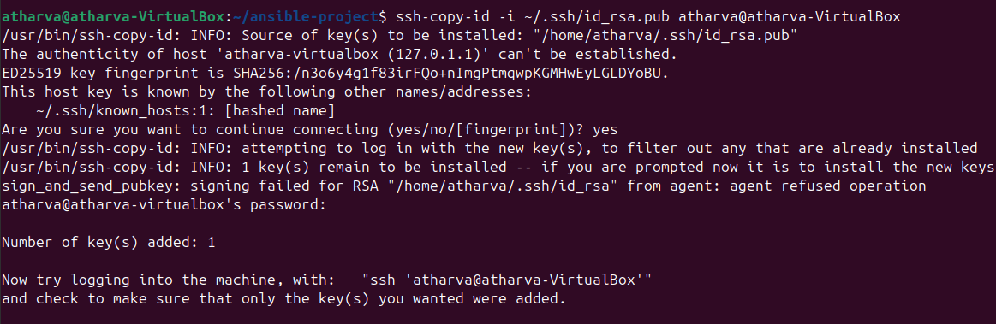

1. Configuring Ansible on the Server

use:  
- sudo nano /etc/ansible/hosts

Now add:

[webserver]

server1 ansible_host=127.0.0.1 ansible_user=atharva ansible_ssh_private_key_file=~/.ssh/id_rsa

127.0.0.1 = IP of the machine

atharva = machine name

~/.ssh/id_rsa = path to the private key

Also Add:

[servers]

server1 ansible_host=127.0.0.1

[all:vars]

ansible_ssh_private_key_file=/home/atharva/.ssh/id_rsa

Now save the file

1. Now set permission to the private key

Only you (the owner) can read and write the private SSH key.

No other users (not even those in your group) can read, write, or execute the file.

This is essential for security because SSH private keys must be kept secret to prevent unauthorized access to serve

Use command:

chmod 600 /home/atharva/.ssh/id_rsa

This will result in:

atharva@atharva-VirtualBox:~$ ls -l /home/atharva/.ssh/id_rsa

-rw------- 1 atharva atharva 1831 Mar 4 08:59 /home/atharva/.ssh/id_rsa



1. connect your own machine (localhost) via SSH

Use command:

ssh -i /home/atharva/.ssh/id_rsa atharva@127.0.0.1

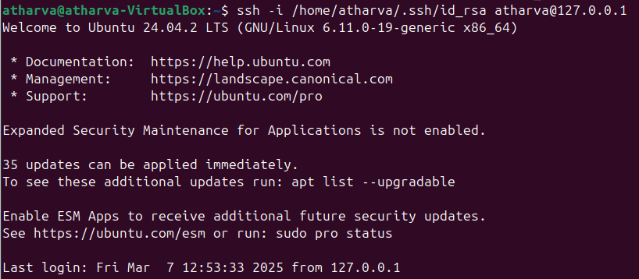

1. Now ping the server  
   Use command:

ansible webserver -m ping

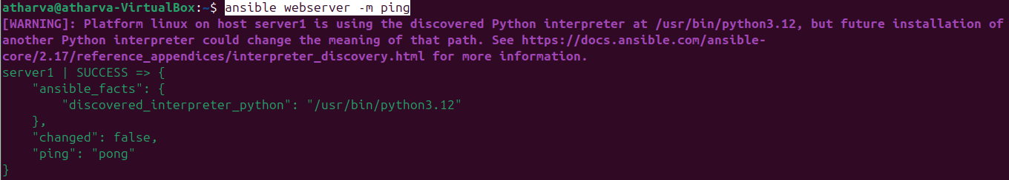

1. Now create a playbook in a directory

Use command:

* mkdir ansible-project →to create the directory
* nano package-playbook.yaml →to create the playbook

In the playbook add the below code and save.

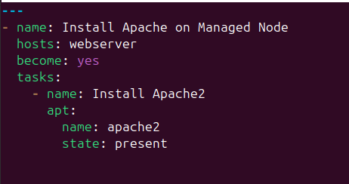

1. Now run the playbook

Use command:

ansible-playbook package-playbook.yaml --ask-become-pass

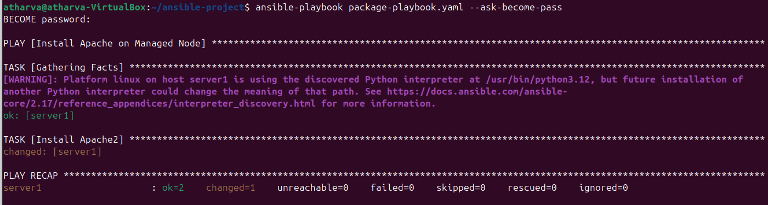

**Conclusion**: This setup automates configuration management using Ansible, making deployments more efficient and reducing manual effort. By using SSH key-based authentication and playbooks, Ansible enables seamless server management, ensuring consistency across environments.